Chapter 8: Reproducing

8.1 There are different ways of reproducing

Literacy support worksheet answers (pages 140–141)

Reproduction

Asexual reproduction

1 What is asexual reproduction?

Asexual reproduction involves a single organism making an exact genetic copy of itself.

2 What is sexual reproduction?

Sexual reproduction combines genetic material from two organisms to produce a new organism.

3 What kind of DNA do the offspring have in asexual reproduction?

They are identical.

4 Describe one advantage and one disadvantage of asexual reproduction and a lack of variation:

a Advantage:

If suited to an environment it could be more successful.

b Disadvantage:

If the environment changes in any way there may be a risk of extinction.

5 Why does the queen bee like parthogenesis?

Her fertilised eggs always become male bees, which means there is no competition for her crown!

6 List three structures that use vegetative reproduction:

Plantlets; stolons; rhizosomes

7 Draw an example of vegetative reproduction below:

Student drawings will vary.

Sexual reproduction

8 What two cells were needed to join, in order to make you?

Gametes – an egg from your mum and sperm from your dad.

9 What does sexual reproduction produce?

Offspring

10 Why is variation within a population important?

It is important because for the survival of a species there must be genetic variation, as each offspring brings a new combinations of features, ensuring better chances of survival.

11 What is the difference between identical and non-identical twins in terms of their DNA?

Identical twins have identical DNA, non-identical twins have different DNA.

Hermaphrodites

12 What is a hermaphrodite?

An organism that has both female and male reproductive organs.

13 Some organisms that are hermaphrodites can ‘turn off’ one sex. Why/when would this be beneficial? Use Figure 8.7 in *Oxford Science 8* to help you.

Beneficial when there is no opposite sex organisms. E.g. in a population of all males, you can become female and reproduce.

Word detective

14 True or false

Read each of the statements below and circle whether it is true or false.

a Binary fission is when an organism splits in half.

T

b Parthenogenesis involves fertilised eggs splitting into new organisms.

F

c Fragmentation is the same as binary fission.

F

d Fragmentation in plants is referred to as vegetative reproduction

T

e Eggs fuse to make new organisms.

F

f Hermaphrodites have female and male reproductive systems.

T

8.2 The female reproductive system produces eggs in the ovaries

Literacy support worksheet answers (pages 142–143)

Female reproduction

1 Label the diagram of the female reproductive system below:

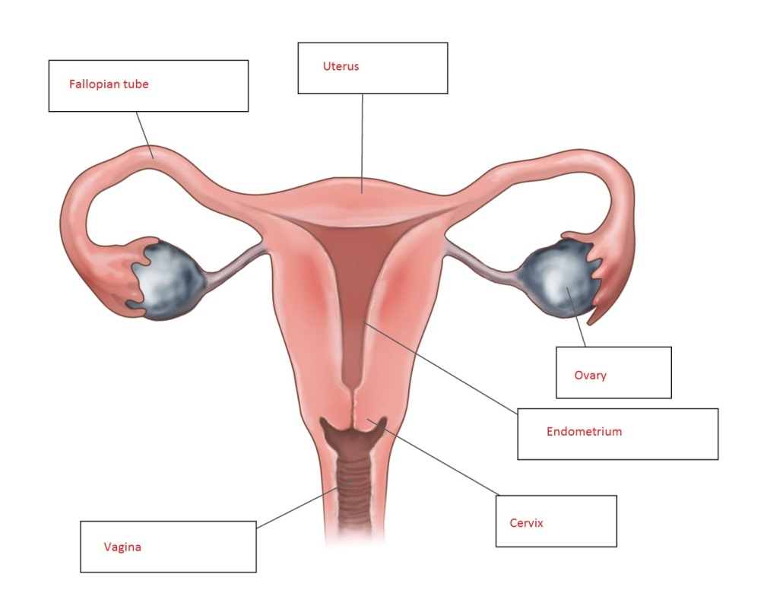

2 Draw a line to match each organ on the left to its function, in the column on the right.

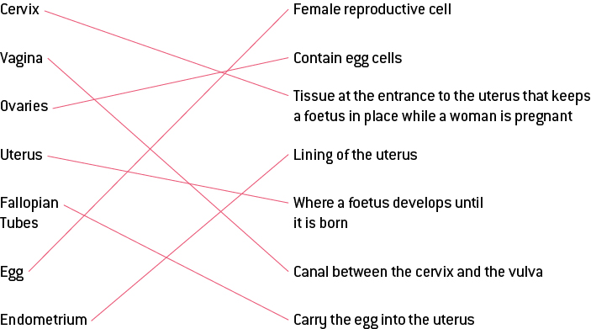

3 What is ovulation?

Every month a chemical messenger from the brain causes one egg to mature and be released. This is called ‘ovulation’.

4 At what age do females first get their period?

This varies widely – usually between 11 and 15 years of age.

5 How long do menstrual periods last?

Approximately 7 days (see figure 8.12)

6 Use figure 8.10 to help you fill in the 28 day menstrual cycle:

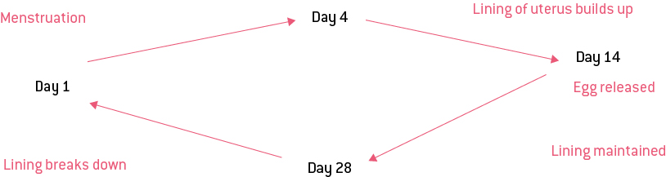

Word detective

7 True or false

Read each of the statements regarding giving birth, and circle whether it is true or false.

a Human mothers go through five stages of childbirth.

F

b The first stage of birth involves the walls of the placenta contracting.

F

c The cervix must open 12 cm before a baby’s head can move through the vagina.

F

d A baby is still attached to the placenta when born.

T

e The umbilical cord attaches the placenta to the mother

T

f Belly buttons are formed from the umbilical cord.

T

g The delivery of the placenta is one of the stages of birth,

T

8.3 The male reproductive system produces sperm in the testes

Literacy support worksheet answers (pages 144–145)

Male reproduction

1 What is the difference between internal and external fertilisation?

Fertilisation of the egg with sperm happens inside the organism (internal), as opposed to outside (external).

2 Provide a brief sentence on what happens during fertilisation:

Male gamete (sperm), meets the female gamete (egg) and fuses to form offspring (zygote).

3 Where is sperm produced?

In the testes

4 Why is the scrotum outside of the body?

So that sperm can be kept below lower than 37ᵒC

5 Label the diagram of the male reproductive system below:

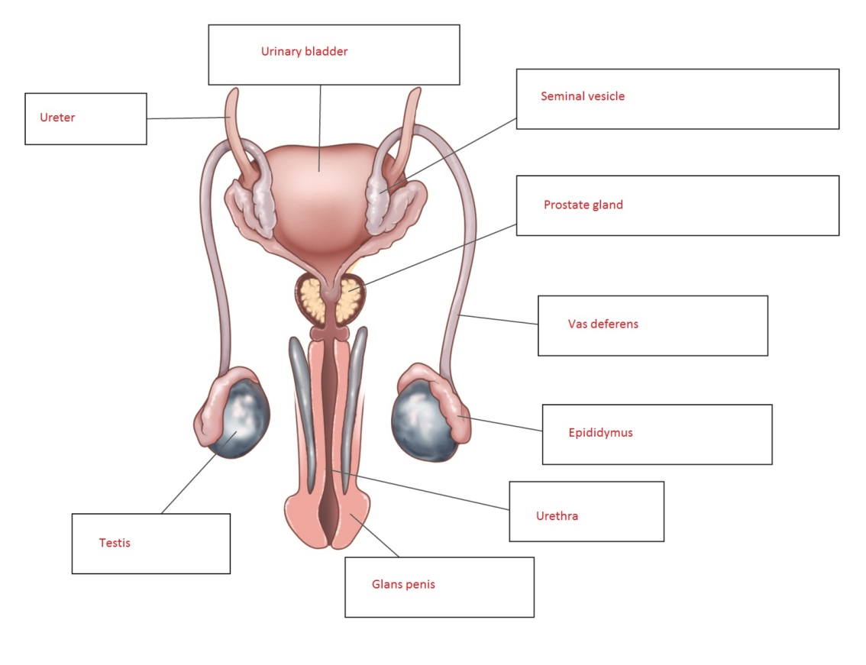

6 Name two monotremes. (They exist only in Australia.)

Platypus and echidna

7 What do birds, reptiles and monotremes have in common in their ability to reproduce?

They all produce eggs.

8 In comparison to humans, name three differences in the way that amphibians and fish reproduce:

• External fertilisation

• Fertilisation occurs in water

• Hundreds of eggs laid at once

9 Complete the table below to compare human male and female reproduction (see pages 140–145):

|  |  |  |
| --- | --- | --- |
| **Characteristic** | **Male** | **Female** |
| What is the gamete called? | sperm | ovum |
| Main hormone? | testosterone | oestrogen |
| Name of gamete producing organ? | testes | ovaries |
| Tubes that provide a pathway for the gamete from where it was produced | vas deferens | fallopian tubes |

Word detective

10 Matching meaning

Draw a line to match the organ on the left to the description of its role on the right.

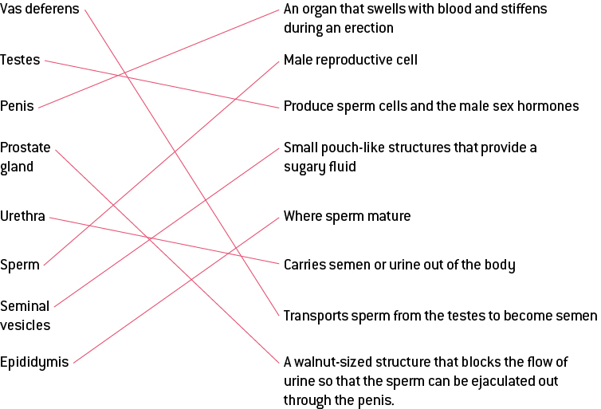

8.4 Science as a human endeavour: Things sometimes go wrong in reproduction

Literacy support worksheet answers (pages 146–147)

Problems in the reproductive system

Endometriosis

1 What is the endometrium?

The lining of the uterus

2 Endometriosis can occur in two places. Where?

• Outside of the uterus

• Spread to organs such as the ovaries

3 Name two ways that endometriosis is like the menstrual cycle.

• Endometrial cells grow

• Endometrial cells break down

4 What are three effects of endometriosis?

• Pain

• Prevents eggs being able to move down fallopian tubes

• Can prevent pregnancy

Human reproduction

5 What is ART?

Assisted reproductive technology

6 What is IVF?

In vitro fertilisation – an egg is fertilised by sperm *in vitro* or in a test tube and begins dividing as it is supposed to. The embryo is transferred into the mother’s uterus to go through a normal pregnancy.

7 What are three benefits of IVF?

• It ensures the egg gets fertilised.

• It ensures the egg is dividing as it is supposed to.

• Unborn babies can be screened for problems.

8 What are the potential problems involved in testing amniotic fluid? See page 146 to help you.

A needle must be inserted through the belly, which can risk infection, or interfere with the pregnancy.

Preserving biodiversity

9 Name four reasons that it is important to stop species from becoming extinct:

• Reliance on different species for food

• Reliance on different species for transportation

• Reliance on different species for tourism

• Balancing of ecosystems

10 What is a captive breeding program?

It is the breeding of animals in zoos and sanctuaries in ideal environments, either naturally or by IVF.

Contraception and desexing

11 What does contraception do?

It stops animals from getting pregnant.

12 What are the benefits of contraception in captivity?

It stops inbreeding and allows animals to be born at a time when there are enough resources and room.

13 What is desexing?

A permanent contraceptive that involves either the vas deferens being tied (in males) or the fallopian tubes being tied (in females).

Word detective

14 Mumbo jumbo

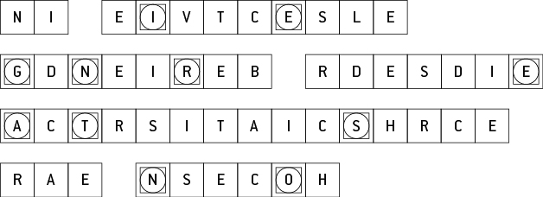

Message: In selective breeding desired characteristics are chosen.

Secret word: generations

8.5 Plant sexual reproduction produces seeds

Literacy support worksheet answers (pages 148–149)

Sexual reproduction in plants

1 Label the reproductive organs of a flower on the diagram below:

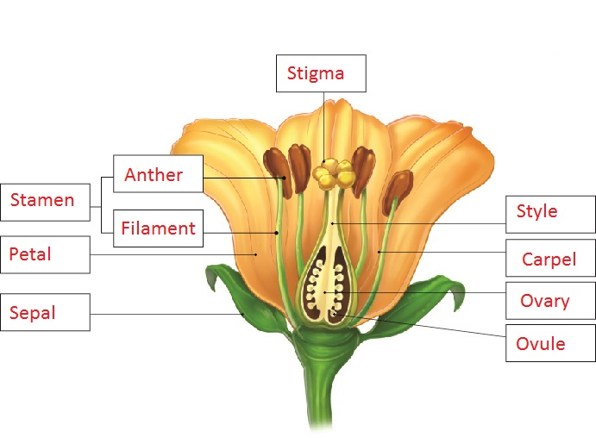

2 Draw a line to match each of the words on the left – the organs in the reproductive system of a plant – with its function, on the right.

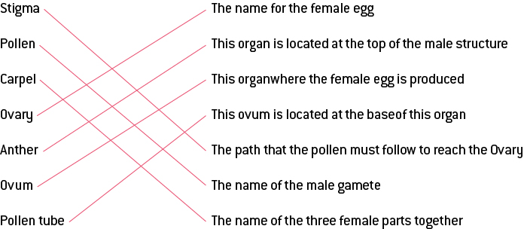

3 Label the structure of the carpel below:

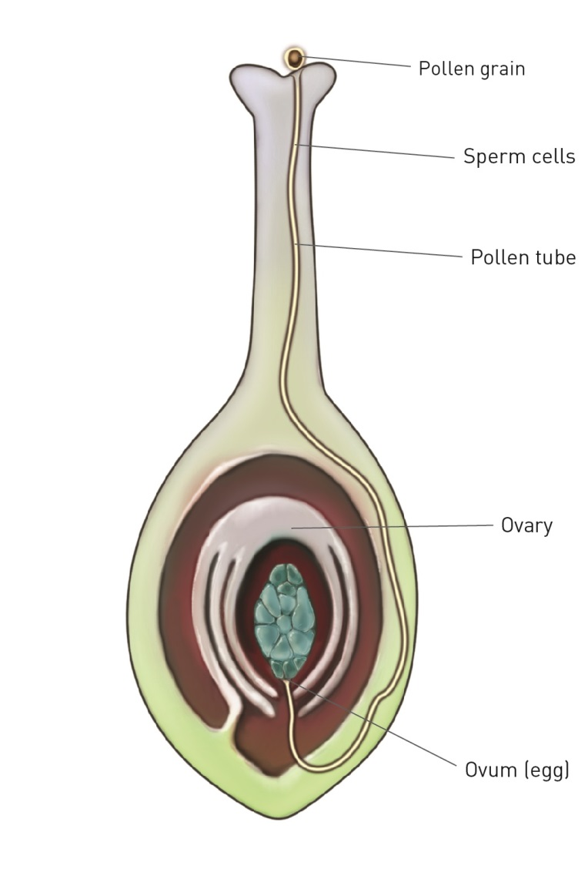

4 Name the three types of pollination and explain how each occur:

• Pollination

• Self-pollination

• Cross-pollination

5 What are spores?

Spores are tiny reproductive structures that grow into plants with both male and female reproductive organs.

6 Use the diagrams on page 149 of your student book to briefly explain how each plant reproduces and how it attracts animals.

|  |  |
| --- | --- |
|  | How does it reproduce?  Cross-pollination: animals transfer the pollen of one plant to the stigma of another plant.  How does it attract animals?  Its smell attracts the animals which transfer the pollen. Also, the bright red colour attracts pollinators. |
|  | How does it reproduce?  Cross-pollination: animals transfer the pollen of one plant to the stigma of another plant.  How does it attract animals?  Its smell attracts the animals which transfer the pollen. |
|  | How does it reproduce?  Cross-pollination: animals transfer the pollen of one plant to the stigma of another plant.  How does it attract animals?  Its bright yellow colour attracts the animals which transfer the pollen. |

Word detective

7 Fill in the gaps

Fill the gaps in the sentences, using the words provided below.

self-pollination zygote sizes cross-pollination

reproductive stigma fertilisation flower

Flowers come in all shapes and sizes. The purpose of a flower is not necessarily to become sweet-smelling and beautiful but to contain the sexually reproductive organs of the plant and to help fertilisation to occur. Self-pollination involves pollen from a flower landing on its own stigma or that of another flower, on the same plant. Cross-pollination occurs when pollen from another plant lands on the stigma of a flower on a different plant. After fertilisation the ovary swells to become a fruit. The fruit provides nutrition for the zygote to grow within the seeds.

8.6 Science as a human endeavour: Reproduction techniques have an impact in agriculture

Literacy support worksheet answers (pages 150–151)

Selective breeding and its impacts

1 What is selective breeding?

Animals and plants are specially bred to keep, lose or enhance certain characteristics by people choosing the ‘partners’.

2 What would be the benefits of breeding a cow that produces lots of milk with a healthy bull?

Female offspring are likely to be good milk producers.

Male offspring are likely to be good meat producers.

3 What are some of the desired characteristics that sperm banks are used for?

a In race horses:

‘staying power’

b In dogs:

facial shape or coat colour

4 How does selective breeding occur in plants?

People breed plants that are better able to survive frost or disease. Or, they can be deliberately cross-pollinated with a type of plant that produces high quality grains, to produce better plants.

5 How can selective breeding put a population at risk of disease?

Less variation in genetic material puts the whole population at an increased risk of disease. If one plant/ animal contracts a disease, the more similar the genetic material, the greater the chance that another member of the population will contract the disease.

6 Many Tasmanian devils are being wiped out due to cancerous tumours.

a How did this happen?

Once one Tasmanian devil contracted it, he/she passed it on genetically.

b What could happen if such a large number continue to die?

They could become endangered or extinct.

7 The great Irish Potato Famine occurred in the 1800s. What happened to the potatoes due to a lack of diversity?

Some potatoes got a fungus and then all of the potato crops were wiped out.

8 What is inbreeding?

Inbreeding is when animals reproduce with animals that are closely related to themselves.

9 What is the result of inbreeding within a population?

Lack of variation in genetic material and rare diseases showing up are some of the results.

Word detective

10 Crossword

Read the clues below and fill in the crossword with answers.

